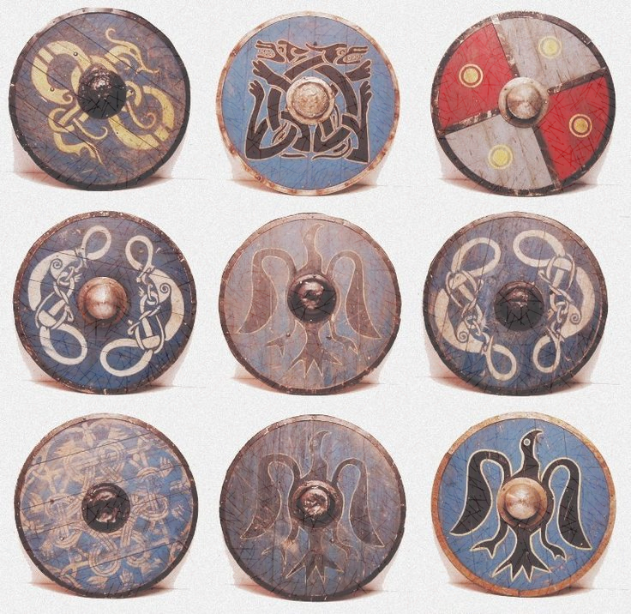

**As Scientists we are learning to:**

* Identify and describe the functions of different parts of a flowering plant.
* Explore what plants need for life and growth and how they vary from plant to plant.
* Investigate the way in which water is transported within plants.
* Explore the part that flowers play in the life cycle of flowering plants, including pollination, seed formation and seed dispersal.
* Research key scientists and discover their scientific discoveries.
* Ask and generate key questions.
* Write instructions and evaluate investigations.

**In RE we are learning about Sikhism and Hinduism.**

**In PE we are learning Dance and Athletics**

**In French we are learning family members**

**In Music we are learning and performing songs.**

**As Geographers we are learning:**

* Name the layers that make up the Earth and key parts of a volcano.
* Explain how to keep safe during an earthquake.
* Describe a tsunami and the damage caused by a tsunami.
* Explain how tornadoes form.
* Describe how scientists collect data about storms.

**As Historians we are learning to:**

* Put events in to chronological order.
* Consider historical events from different points of view.
* Understand who the Vikings were and where they came from.
* Understand what life was like in Anglo-Saxon Britain.
* Share our own opinions about historical events.

**As Artists we are learning to:**

* Appraise the work of Henry Moore.
* Consider Henry Moore’s style and create sketches based on his art.
* Create miniature sculptures in the style of Henry Moore.

**Curriculum Leaflet Year 3 Pegasus Class Summer 2019**

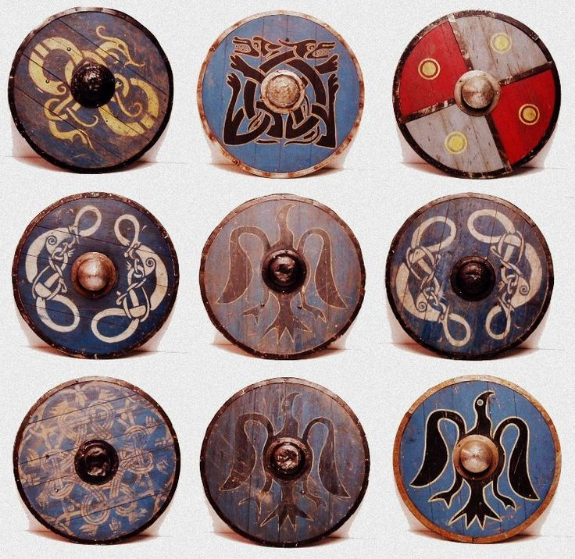

**As Mathematicians we are focusing on:**

* **Fractions**
* Recognise and use fractions as numbers: unit fractions and non-unit fractions with small denominators.
* Compare and order unit fractions, and fractions with the same denominators.
* Recognise, find and write fractions of a discrete set of objects: unit fractions and non-unit fractions with small denominators.
* Count up and down in tenths.
* **Shape, Space and Measure**
* compare and classify geometric shapes, including quadrilaterals and triangles**,** based on their properties and sizes
* describe positions on a 2-D grid as coordinates in the first quadrant

**We are also working on our mathematical skills such as fluency, reasoning and problem solving using a range of different resources.**

**As Writers we are learning to:**

* Gather ideas and vocabulary from our own reading
* Edit and improve our writing by discussing ideas with others
* Use paragraphs to structure our writing
* Write a story based on a fairy tale.
* Use our writing skills in other areas of our learning.
* Write an explanation text
* Look at the writing of Michael Morpurgo.
* Consider the tense we are writing in.
* Start using a wider range of punctuation including inverted commas.

**As Readers we are learning to:**

* Read a range of different text types, both independently and at home.
* Use dictionaries to find the meaning of words
* Continue to develop our comprehension and reading skills.
* Read and discuss texts looking specifically at reading skills.
* Comparing texts by identifying similarities and differences.
* Use reading skills and scanning skills to find information.

**Curriculum Leaflet Year 3 Pegasus Class Summer 2019**