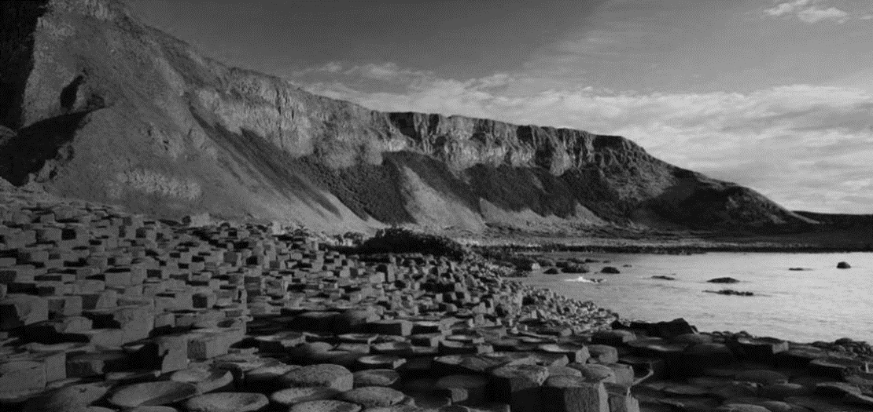

**Homework is set on Fridays back in by following Wednesday. Spellings are tested and new lists set on Fridays. Reading and times tables should be practised at home daily. Reading diaries need to be signed and in school every day. PE is on Wednesdays and Friday.**

**Swimming for some children is in on Monday and some on Tuesday-EVERYONE swims on Friday.**

**In our Science we will be:**

* **Sorting and classifying animals**
* **Learning about different habitats**
* **Comparing and contrasting animals and how they adapt to different habitats**
* **Learning about the seaside as a habitat**

**Through PSHE**

* **Stay safe on the internet**
* **Consider how we can make good choices and resist peer pressure**
* **Develop our understanding of positive relationships**

**In our other Foundation Subjects we will be:**

* **In French we will be learning the names of foods and we will be writing simple sentences in French.**
* **We will be learning how to ask and answer questions in French and we will be extending our knowledge of French vocabulary so that we can have a simple conversation in French**
* **In RE we will be learning about Hinduism learning about Brahma and Hindu feasts**
* **In Design Technology we will be making bread and designing picnic loaves.**
* **In music we will be developing our singing and performance skills through practising for the end of year production.**
* **In PE we will be developing catching and throwing skills in Rounders and improving our fitness levels and resilience in Athletics**

**As Geographers, we will be finding out more about the coastlines around Britain**

* **Learning about key landmarks on the British coastline**
* **How the coastline differs around Britain and what has created these differences**
* **The importance of these coastlines for tourism and leisure.**

**The British Coast Line**

**SUMMER TERM LEPRECHAUN CLASS**